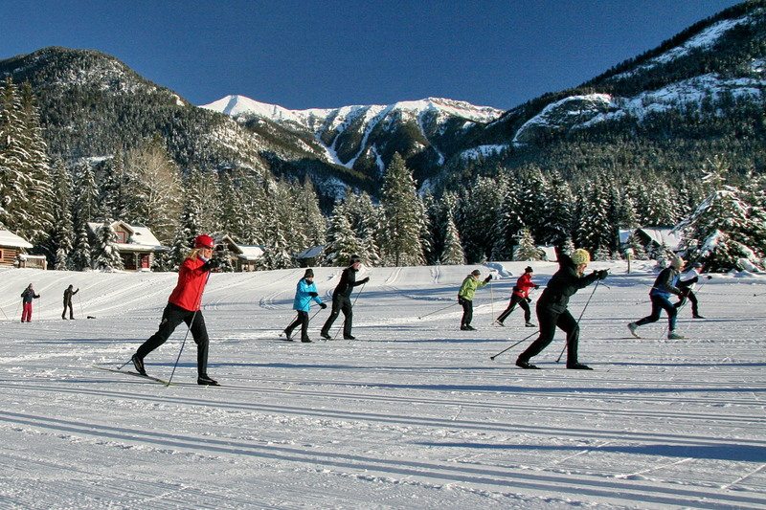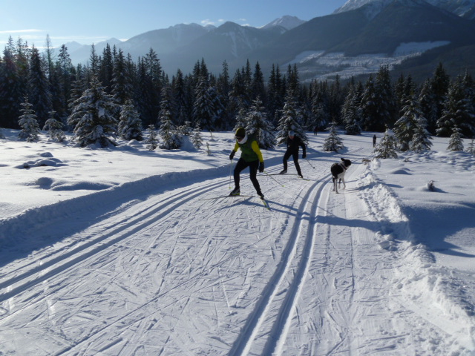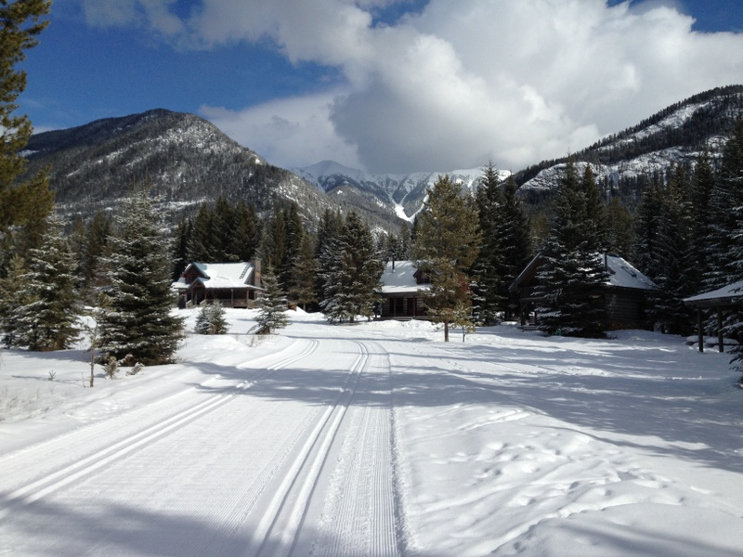

This instructional cross country ski week is the perfect skiing holiday for the novice to advanced cross country skier. Great trails, expert coaching, fun & adventure make this an experience you will not forget. Nipika's Learn to Cross Country Ski Week includes accommodation for 5 nights, all meals; coaching in classic and skate skiing, theory sessions, personal technique video analysis, trail fees, social activities, and waxes. Participants are required to bring their own skis, boots, poles, (rental ski equipment is available on request), warm clothing and beverages of choice.

Your Coaches for the week:

[Lyle Wilson](http://www.nipika.com/people), past Olympic and World Championships Coach for Canada, Level IV NCCP & Level IV CANSI certified, past Canadian Masters Ski Champion & active ski racer. 2011 Masters World Cup - silver & bronze medalist.

Wendy Grater, Level IV CANSI & Natn. Technical Committee member, reigning National Masters Champion & past World Masters medalist & active ski racer.

Phil Wood, waxing tech and guide for visually impaired athlete in the 2014 Sochi Paralympic Games. Phil was a coach with the Canmore Nordic team for a number of years before he started work at Nipika.

# What you get!

The accommodations for the week are at Nipika Mountain Resort. You will get a bed in one of the cozy, hand build log cabins. All cabins are equipped with bedding, linens, towels, paper products, soap. Each cabin has a fully stocked kitchen and barbeque for you to use. All meals are included in the price!

Cost per person: $1050.00 CDN plus taxes

Cost for “Private Room” per person: $1250.00 CDN plus taxes

If you have any questions, or would like to book, please contact us:

[info@nipika.com](mailto:info@nipika.com)

1-877-657-4525

### Accommodations

**Cross Country Ski Week**

**in the**

**Rockies**

Nipika Mountain Resort - January 18-23, 2015

Morning: downhill techniques on skate skis. Afternoon: long slow distance classic ski. Evening: social activities in Lodge (hot tub & sauna)

Morning: interval session on skis. Afternoon: yoga session in the barn. Evening: fitness & training principals for all ages. Video Running With Wolves

##### Day 5

Morning: classic technique session. Afternoon: skate technique session. Evening: individual technique video review & World Cup Videos

Check out equipment, morning: classic ski session. Afternoon: Skate tour of trail system. evening waxing & ski base preparation.

Arrival, check in, dinner & welcome reception. Ski videos in the Rocky Mountain Lodge.

##### Day 1

##### Day 2

##### Day 3

##### Day 4

#### Save the date! January 18-23, 2015